WEEK 1
MOCKITO EXERCISES
Exercise 1: Mocking and Stubbing
package com.example;
import static org.mockito.Mockito.*;
import org.junit.Test;
import static org.junit.Assert.assertEquals;

public class MyServiceTest {
@Test
public void testExternalApi() {
// Arrange: create mock
ExternalApi mockApi = mock(ExternalApi.class);

// Stub: define behavior
when(mockApi.getData()).thenReturn("Mock Data");

// Act: use service with mock
MyService service = new MyService(mockApi);
String result = service.fetchData();

// Assert: verify result
assertEquals("Mock Data", result);
}
}

package com.example;

public interface ExternalApi {
String getData();
}

package com.example;

public class MyService {
private final ExternalApi api;

public MyService(ExternalApi api) {
this.api = api;
}

public String fetchData() {
return api.getData();
}
}

OUTPUT: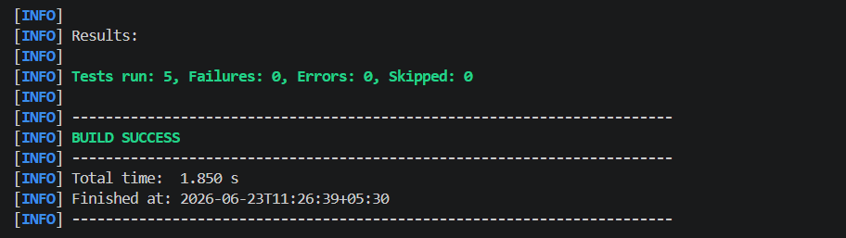

Exercise 2: Verifying Interactions with Mockito.
package com.example;

import static org.mockito.Mockito.*;
import org.junit.Test;

public class MyServiceVerifyTest {
@Test
public void testVerifyInteraction() {
// Arrange: create mock
ExternalApi mockApi = mock(ExternalApi.class);

// Act: call the service
MyService service = new MyService(mockApi);
service.fetchData();

// Assert: verify that getData() was called once
verify(mockApi).getData();
}
}

OUTPUT:
